ASSIGNMENT 4 (Week 6)

Andrew Jordan

2022-04-19

# Markdown Basics

## Favorite Foods

1. Pizza
2. Gnocchi
3. Crab

## Images

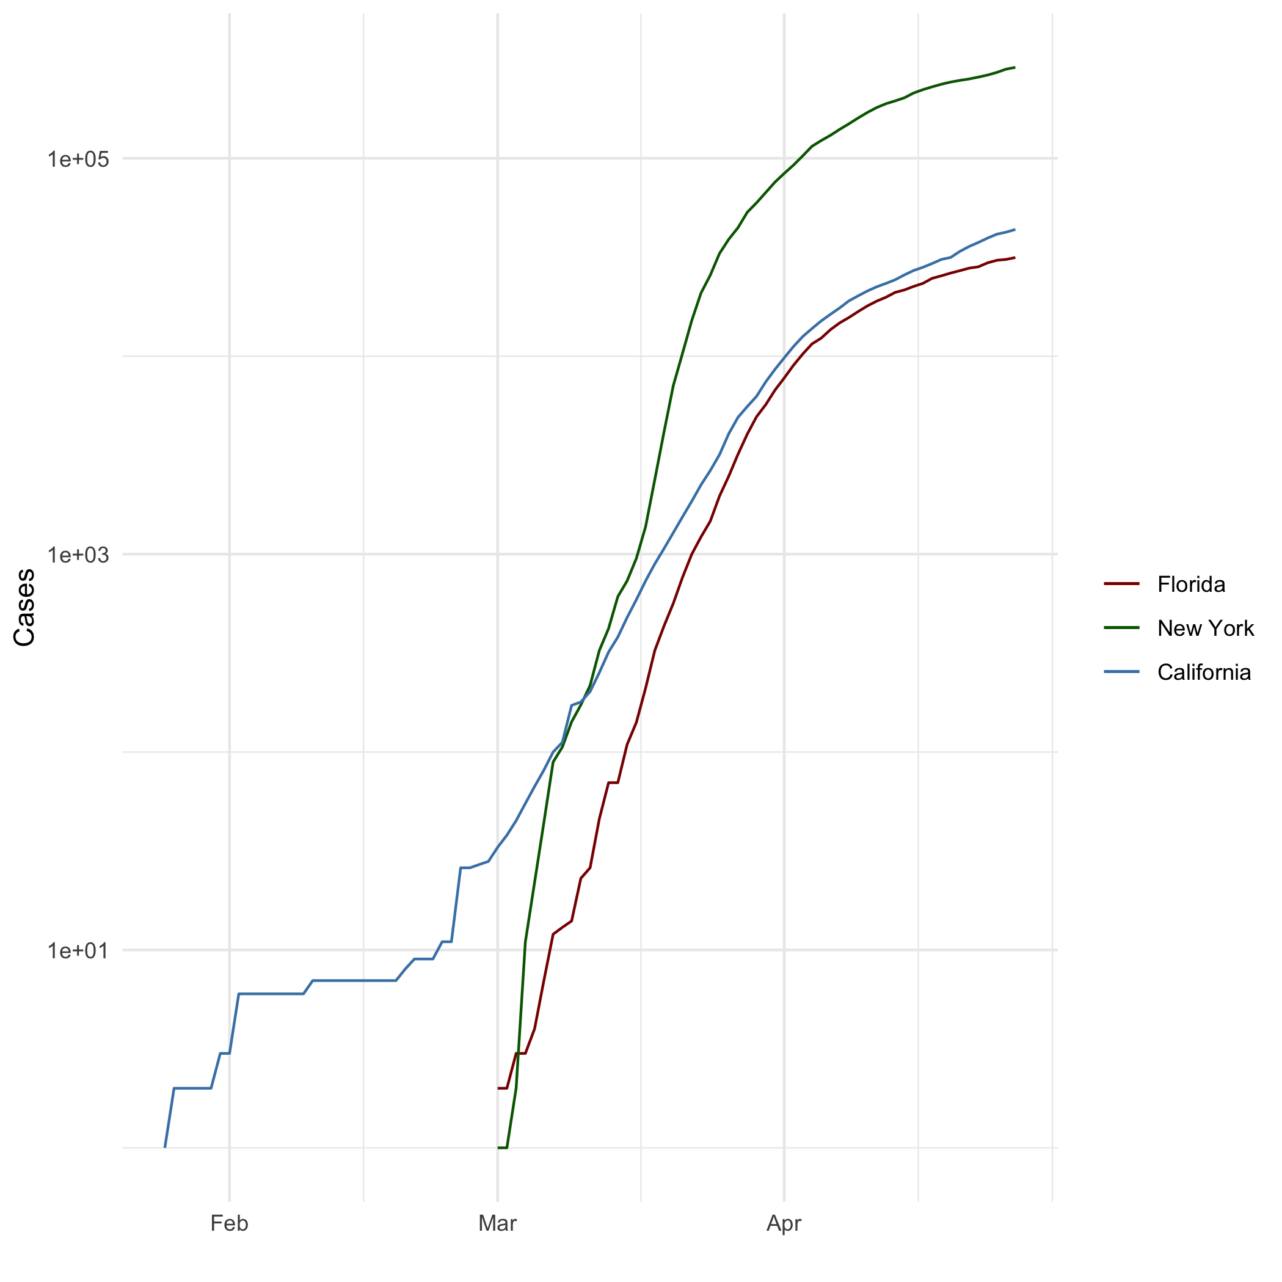

All Cases (Log Plot)

## Add a Quote

“It’s the job that’s never started as takes longest to finish”–Samwise Gamgee, Mayor of the Shire

## Add an Equation

$$E=mc^{2}$$

## Add a Footnote

This is a footnote[1]

## Add Citations

* R for Everyone (Lander 2014)
* Discovering Statistics Using R (Field, Miles, and Field 2012)

# Inline Code

## NY Times COVID-19 Data

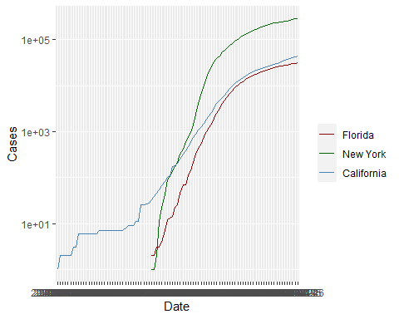

## R4DS Height vs Earnings

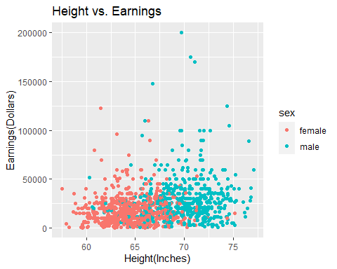

# Tables

## Knitr Table with Kable

One Ring to Rule Them All

| name | race | in_fellowship | ring_bearer | age |
| --- | --- | --- | --- | --- |
| Aragon | Men | TRUE | FALSE | 88 |
| Bilbo | Hobbit | FALSE | TRUE | 129 |
| Frodo | Hobbit | TRUE | TRUE | 51 |
| Galadriel | Elf | FALSE | FALSE | 7000 |
| Sam | Hobbit | TRUE | TRUE | 36 |
| Gandalf | Maia | TRUE | TRUE | 2019 |
| Legolas | Elf | TRUE | FALSE | 2931 |
| Sauron | Maia | FALSE | TRUE | 7052 |
| Gollum | Hobbit | FALSE | TRUE | 589 |

## Pandoc Table

+--------+--------+----------------+-----------------+------+  
| Name | Race | In Fellowship? | Is Ring Bearer? | Age |  
+========+========+================+=================+======+  
| Aragon | Men | YES | NO | 88 |  
+--------+--------+----------------+-----------------+------+  
| Bilbo | Hobbit | YES | YES | 129 |  
+--------+--------+----------------+-----------------+------+  
| Frodo | Hobbit | YES | YES | 51 |  
+--------+--------+----------------+-----------------+------+  
| Sam | Hobbit | YES | YES | 36 |  
+--------+--------+----------------+-----------------+------+  
| Sauron | Maia | NO | YES | 7052 |  
+--------+--------+----------------+-----------------+------+  
  
Table: One Ring to Rule Them All

# References

Field, A., J. Miles, and Z. Field. 2012. *Discovering Statistics Using r*. SAGE Publications. <https://books.google.com/books?id=wd2K2zC3swIC>.

Lander, J. P. 2014. *R for Everyone: Advanced Analytics and Graphics*. Addison-Wesley Data and Analytics Series. Addison-Wesley. <https://books.google.com/books?id=3eBVAgAAQBAJ>.

1. No it isn’t, THIS is a footnote